**What’s AWS?**

* AWS (Amazon Web Services) is a Cloud Provider
* They provide you with servers and services that you can use on demand and scale easily
* AWS has revolutionized IT over time
* AWS powers some of the biggest websites in the world
  + Amazon.com
  + Netflix

**AWS Global Infrastructure**

* AWS Regions
* AWS Availability Zones
* AWS Data Centers
* AWS Edge Locations / Points of Presence
* <https://infrastructure.aws/>

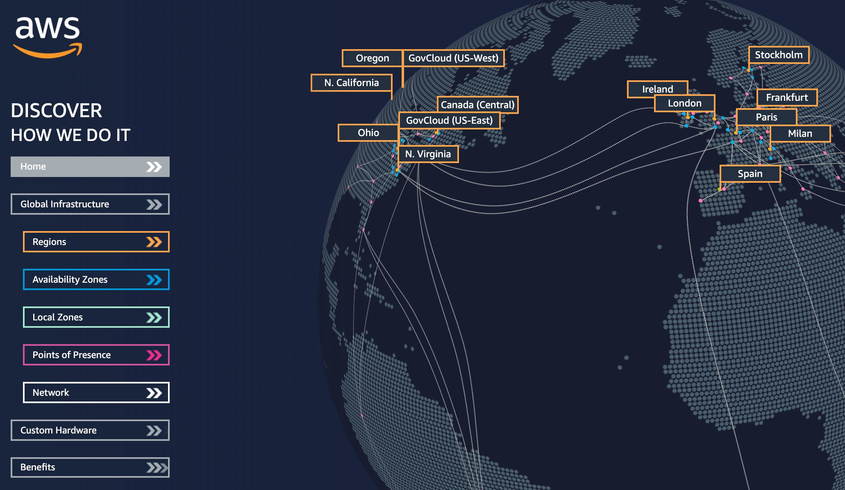

**AWS Regions**

* AWS has Regions all around the world
* Names can be us-east-1, eu-west-3…
* A region is a cluster of data centers
* Most AWS services are region-scoped

**How to choose an AWS Region?**

If you need to launch a new application, where should you do it?

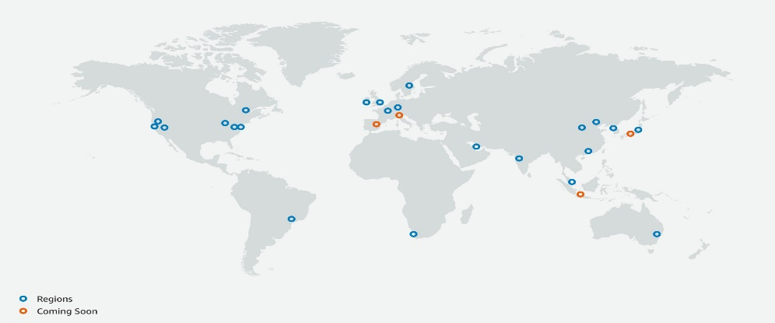

?

?

?

?

* Compliance with data governance and legal requirements: data never leaves a region without your explicit permission
* Proximity to customers: reduced latency
* Available services within a Region: new services and new features aren’t available in every Region
* Pricing: pricing varies region to region and is transparent in the service pricing page

**AWS Availability Zones**

* Each region has many availability zones (usually 3, min is 2, max is 6). Example:
  + ap-southeast-2a
  + ap-southeast-2b
  + ap-southeast-2c
* Each availability zone (AZ) is one or more discrete data centers with redundant power, networking, and connectivity
* They’re separate from each other, so that they’re isolated from disasters
* They’re connected with high bandwidth, ultra-low latency networking

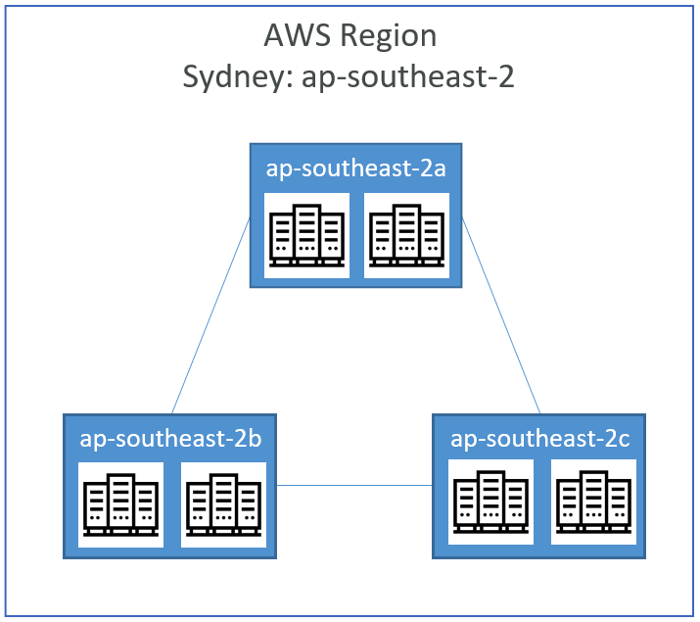

**AWS Points of Presence (Edge Locations)**

* Amazon has 216 Points of Presence (205 Edge Locations & 11 Regional Caches) in 84 cities across 42 countries
* Content is delivered to end users with lower latency